BCIA HRV Workshop, 28 & 29 August 2017 at Hotel Kurrajong, Canberra

This 15-contact-hour workshop is designed for biofeedback/neurofeedback practitioners, psychologists, clinical counsellors, clinical social workers, marriage and family therapists, nurses, physicians, and other health care professionals and academicians interested in utilizing heart rate variability (HRV) biofeedback in their practice or research. This workshop will cover all 15 hours of the BCIA HRV Biofeedback Certificate of Completion Blueprint and will cover cardiac anatomy and physiology, respiratory anatomy and physiology, autonomic nervous system anatomy and physiology, heart rate variability, HRV instrumentation, HRV measurements, HRV biofeedback training strategies, and HRV biofeedback applications. Attendees will complete BCIA's 15-hour didactic requirement for the HRV Biofeedback Certificate of Completion. Attendees will gain practical knowledge about HRV and breathing assessment and training.

About Fred Shaffer, Ph.D.
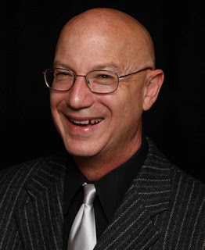
Fredric Shaffer, PhD, BCB is a biological psychologist and professor of Psychology and former Department Chair at Truman State University, where he has taught since 1975 and has served as Director of Truman’s Center for Applied Psychophysiology since 1977. In 2008, he received the Walker and Doris Allen Fellowship for Faculty Excellence. In 2013, he received the Truman State University Outstanding Research Mentor of the Year award. Dr. Shaffer is a co-editor of Evidence-Based Practice in Biofeedback and Neurofeedback (3rd ed.). He is a co-editor with Donald Moss of Foundations of Heart Rate Variability Biofeedback: A Book of Readings. He co-authored with Rollin McCraty and Christopher Zerr, the Frontiers in Psychology review article "A healthy heart is not a metronome: An integrative review of the heart's anatomy and heart rate variability." Finally, he co-authored with Rollin McCraty, the Global Advances in Health and Medicine review article, "Heart rate variability: New perspectives on physiological mechanisms, assessment of self-regulatory capacity, and health risk." He is a contributing editor for the journal Applied Psychophysiology and Biofeedback. His current research focuses on techniques to increase heart rate variability biofeedback. Dr. Shaffer is a BCIA Senior Diplomate in Biofeedback. Dr. Shaffer is the Chair of the Biofeedback Certification International Alliance (BCIA) and Treasurer for the Association for Applied Psychophysiology and Biofeedback (AAPB).

REGISTER LINK

